Using these templates

If a cover page is required for your document, please use the Cover Page button from Word’s Insert tab:

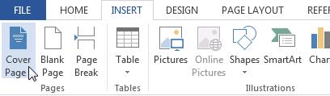

There are three cover page options to choose from, all appearing at the beginning of the list. The cover page can be removed from the same menu by selecting ‘Remove current cover page’

A note on the security level feature:

The security level for the document created appears in 3 places: On the first page in the top table, on the second page in the top table, and in the footer of the document. On the first page it is available as a drop-down menu where you can select the appropriate security level from a list. On the second page, the level must be typed. This is to allow it to automatically appear in the document footer along with the tracking number. The tracking number will automatically update throughout the document when it is changed on the first page.

Inserting and using tables

|  |  |  |  |
| --- | --- | --- | --- |
|  |  |  |  |
|  |  |  |  |
|  |  |  |  |
|  |  |  |  |

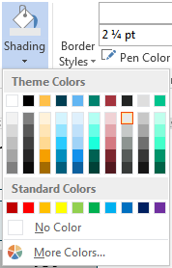

There is a default table style set up in the template. When you insert a new table, it will appear as above. If you do not need a header row or a first column, they can be turned off in the design tab of the Table Tools menu. Text will automatically be formatted correctly if you use the HUD_Body style. If you need a shaded section in the table, you can use the colour shown in the shading drop-down which is in the Design tab of the Table Tools menu.

If you need another block which is the same colour as the header row,   
use the More Colours button and enter the custom colour   
Red: 225, Green: 233, Blue: 235.

Pasting content from other documents

Pasting content from other Word documents may bring the styles associated with the source document along with the content itself. This happens when you use the destination theme which is Word’s default behaviour. If your pasted content looks different from the rest of the document, please reapply the styles using the built-in ones with the prefix HUD. If your content is text only, the safest option is to use the Keep Text Only when pasting. If your content also contains images or tables, you can use the Merge Formatting option to save some time. You will see a clipboard button pop up when you paste content which allows you to change the settings for pasting.

Following are the styles available to use. Please ensure all content inserted into the document uses these.

HUD_Title

HUD_Heading

The HUD_Heading style is used in tables where a title is required which is not in the first row of the table. The **Background** and **Next Steps** titles in the above table for instance. The default table style automatically applies this to the header row so HUD_Body can be used in most cases.

Other styles included in this template are as follows:

HUD_Subheading

HUD_Subheading 2

HUD_Body

HUD_Indented

HUD_List

HUD_Bullets